
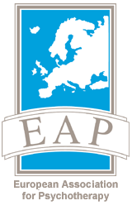
EAP NEWSLETTER

AN OCCASIONAL COMMUNICATION FROM THE EUROPEAN ASSOCIATION FOR PSYCHOTHERAPY

September 2012

FEAP is to be congratulated on producing an impeccably organized Congress, in a beautiful setting, with a splendid scientific programme and a social programme to delight the heart (and the stomach!)

In this issue, we point to the next ‘meg-conference’ in Russia - a programme that has endless possibilities and an outstanding event in the world of psychotherapy.

We also highlight Congresses worldwide, put on by our family of psychotherapy organizations in the World Council.

Along side them are brief introductions to the world of Psychodrama and the way in which psychotherapy is developing in Kosova.

I would also like to draw your attention to a statement by the American Psychological Association, very positive about the effective-ness of psychotherapy. Although presented in formal language, it is an important statement, which also points to a huge amount of research to back up their claim.
Visit the following link:

http://www.apa.org/news/press/releases/2012/08/resolution-psychotherapy.aspx

Adrian M. Rhodes,
President, EAP
September 2012

Dear EAP Psychotherapist,

The principle journal of the EAP is, of course, the International Journal of Psychotherapy, the current issue of which is a special issue:

Volume 16, Number 2, July 2012: A Special Issue on Roberto Assagioli & Psychosynthesis

Full details are on the IJP website: www.ijp.org.uk

Alongside that, we hope that this occasional Newsletter from the European Association for Psychotherapy will prove interesting, stimulating but not too demanding to read.

Its purpose is to offer ECP holders and Individual Members of the EAP, a place to whet the appetite, to point to aspects of psychotherapy, which may be of interest to you.

This issue of the Newsletter comes soon after a highly successful Congress in Valencia, hosted by the Spanish Federation of Associations of Psychotherapists (FEAP) on the subject,
“Improving mental health and emotional well being in Europe.”

European Association for Psychotherapy
Schnirchgasse 9a/4th floor/410, A-1030 Vienna, Austria - www.europsyche.org

European Association for Psychotherapy
Schnirchgasse 9a/4th floor/410, A-1030 Vienna, Austria - www.europsyche.org

Psychodrama was founded in Vienna by JL Moreno MD. Much of his inspiration came from observing children at play. He envisaged encouraging individuals to reawaken their sense of play and through this address their inner conflicts and expand their response to situations.

The belief that the body remembers what the mind forgets is the basis for re-visiting, through enactment, events from the past in order to gain better understanding of the “why” and discover strategies to move forward.

There are techniques within psychodrama which are the driving force of the work:

- Scene setting; encouraging the client to set the scene where an event took place deepens the embodiment of the work and aids the group understanding of the dilemma. The first scene to be set is often a recent past and serves as a pointer to the root of the issue.

- Role Setting; the client is invited to, as it were, stand in the shoes of a significant other. Through this action the client sets the role for another group member but more importantly can begin to experience how it must have been to be that other. There are certain times when it is not appropriate to ask the client to set a role most importantly when it is clear that the significant other is an abuser.

- Role reversal; the client role reverses with the significant in order to access a deeper answer.

Psychodrama an Action Method of Group Psychotherapy

- Doubling; a technique of atunement by another group member which aid the client in speaking words they might be in the habit of censoring.
- Mirroring; the client has the opportunity to step out of a scene and use their adult knowledge to inform “what might have/should have happened” or might give insight as to the “why”
Psychodrama is suitable for most individuals who would be selected for group psychotherapy. It is practiced as a stand alone therapy or as part of a full psychotherapy where it is combined with analytic groups work, art and music.

Psychodrama as the title states is a group psychotherapy. I cannot end this article without stating that psychodrama can also be undertaken in an individual setting where objects rather than people hold the roles of significant other. Individual psychodrama is very suitable for individuals who are perhaps too vulnerable to use the challenge of a group. Since in individual work, using objects the effect can often be to work in miniature thus giving safe distance.

I would not want to list one or two of my favourite practitioners but to guide you to some websites:
www.fepto.eu or www.psychodrama.org (this being the British Psychodrama Association website.)

On either of these sites you will find extensive information about the development of psychodrama, past and present authors and many psychodrama events where you might want to dip a toe.
Celia Scanlan 28th June 2012


MONTH, YEAR VOL # ISSUE #

Delete box or place a cption here.
Delete box or place a caption here.
Continue newsletter text here. Continue newsletter text here. Continue newsletter text here. Continue newsletter text here. Continue newsletter text here. Continue newsletter text here. Continue newsletter text here. Continue newsletter text here. Continue newsletter text here. Continue newsletter text here. Continue newsletter text here.
Continue newsletter text here. Continue newsletter text here. Continue newsletter text here. Continue newsletter text here. Continue newsletter text here. Continue newsletter text here.
Continue newsletter text here. Continue newsletter text here. Continue newsletter text here. Continue newsletter text here. Continue newsletter text here. Continue newsletter text here. Continue newsletter text here.
Continue newsletter text here. Continue newsletter text here. Continue newsletter text here. Continue newsletter text here. Continue newsletter text here. Continue newsletter text here. Continue newsletter text here. Continue newsletter text here.

HEADLINE
SUBHEAD. SUBHEAD.
SUBHEAD. SUBHEAD.




European Association for Psychotherapy
Schnirchgasse 9a/4th floor/410, A-1030 Vienna, Austria - www.europsyche.org

- Kosova Body Psychotherapy Association – NOKTA since 2007 organized more than 25 training seminars and workshops for participants and their members with three international and local body psychotherapy trainers who are listed in EABP register, such as Christina Baden-Johansson, Sibylle Huete – Krafft, Ingeboarg Jochahim and Enver Cesko After four years of training and fulfilling the curriculum with criterias according the EABP standards, 10 trainees passed successfully their exam to be come the professional body psychotherapists. All of them now are in the process of fulfilling the practical hours and supervision sessions to become the full accredited professional members in EABP. New groups of participants are running still.

- Kosoca Centre for Positive Psychotherapy – KCPP since 2008 was organized two levels of training seminars on Positive Psychotherapy; one is Basic Course and second is Master Course. Till now more than 250 participants finished and got their Basic Course Certificates on Positive Psychotherapy and large numbers of participants from Basic Course continued with second level in Master Course. After three years of training in master Course, 14 trainees successfully passed their exam according the standards of World Association for Positive Psychotherapy-WAPP. Involved trainers were well-known trainers from Positive Psychotherapy, as Nossrat Peseschkian, Hamid Peseschkian, Arno Remmers, Gabriela Hum, Gunther Hubner, Navid Peseschkian, Enver Cesko, etc
Kosova Association for Psychotherapy – KAP, as a young National Umbrella Organization -NUO in last four years is very much engaged in different professional activities not only in the promoting of psychotherapy but also developing itself.

In its organization are promoting different modality approaches that are organizing professional training seminars with international trainers compatible for accredited from international psychotherapy organizations.
KAP in his umbrella has three accredited professional organizations;

- Kosova Centre for Positive Psychotherapy – KCPP who is the full accredited member of World Association for Positive Psychotherapy-WAPP,
- Kosova Body Psychotherapy Association – NOKTA who is accepted as organizational member of European Association for Body Psychotherapy –EABP,
- Kosova Centre for Cognitive Behavioral Therapy- KCCBT who is still in the process of consolidation and not so active in professional trainings last three years.

Since two years a new established Kosova Center for Family Therapy is running with organizing the training seminars with some international trainers from different Family Therapy Organisations. This Center is not yet a member of KAP.

The two organizational members of KAP, NOKTA and KCPP are very active in organizing the training seminars.

Kosova Association for Psychotherapy- KAP

Delete box or place a caption here.
MONTH, YEAR VOL # ISSUE #

Delete box or place a cption here.
Delete box or place a caption here.
Continue newsletter text here. Continue newsletter text here. Continue newsletter text here. Continue newsletter text here. Continue newsletter text here. Continue newsletter text here. Continue newsletter text here. Continue newsletter text here. Continue newsletter text here. Continue newsletter text here. Continue newsletter text here.
Continue newsletter text here. Continue newsletter text here. Continue newsletter text here. Continue newsletter text here. Continue newsletter text here. Continue newsletter text here.
Continue newsletter text here. Continue newsletter text here. Continue newsletter text here. Continue newsletter text here. Continue newsletter text here. Continue newsletter text here. Continue newsletter text here.
Continue newsletter text here. Continue newsletter text here. Continue newsletter text here. Continue newsletter text here. Continue newsletter text here. Continue newsletter text here. Continue newsletter text here. Continue newsletter text here.

HEADLINE
SUBHEAD. SUBHEAD.
SUBHEAD. SUBHEAD.

European Association for Psychotherapy
Schnirchgasse 9a/4th floor/410, A-1030 Vienna, Austria - www.europsyche.org

Eurasian Congress for Psychotherapy
(XIX Congress of the European Association for Psychotherapy
and
VII Pan Asian Congress for Psychotherapy).

Dear colleagues and friends!
The organization of the next European congress for Psychotherapy is in progress!
We are glad to present you the official homepage and the folder of the first united Eurasian Congress for Psychotherapy (XIX Congress of the European Association for Psychotherapy and VII Pan Asian Congress for Psychotherapy).

<Psychotherapy without borders:
past, present and future>

www.eurasian-psychotherapy.com/main-en.html
and will be thankful for giving the information of the congress to your organizations and colleagues.
For more information please contact the manager for the international relations Ms. Ekaterina Makarova: kmoppl@mail.ru cell.
RUS: +79165075810; cell AUT: +436602120433
See you in Moscow!
With Best Regards
Viktor Makarov, Ekaterina Makarova and the executive committee of the congress

Kosova Center for positive Psychotherapy had honor and great pleasure to be the organizer of 1st International Conference on Positive Psychotherapy which was held in Prishtina-Kosovo from 7-10 June 2012.

Conference was organized in collaboration with WAPP and with small donation of Kosovo Ministry of Health. It was present 7 country representatives such as Albania, Macedonia, Germany, Turkey, Poland, USA and Ukraine with more than 100 participants.

During the four days of Conference activities it was 24 workshop presentations from different young enthusiastic participants, 8 key plenary presentations, one move presentation, 1 psycho-drama group presentation and one study presentation about the DAI and WIPPF.

This was first large and great experience not for the Kosova Center for Positive Psychotherapy, but also new challenges in traditional concept of psychotherapy toward the psychiatry, psychology and medicine with new concepts.

In the end of this report, it is good to mention that Ministry of Health was asked from KAP to send the draft of curriculum for applying the Psychotherapy in Mental Health System, how the place of profession of psychotherapy will take in Medical Chamber together with three mainstream professions like as Medicine, Psychology and Psychotherapy. We are hoping that this medical Chamber first will be voted in Kosovo Assembly and than profession of psychotherapy will be accepted as legal and official profession.
Prishtina, 01. August. 2012. MSc. Enver Cesko
President of KAP and
Board member of EAP

Kosova Association for Psychotherapy - Contd.
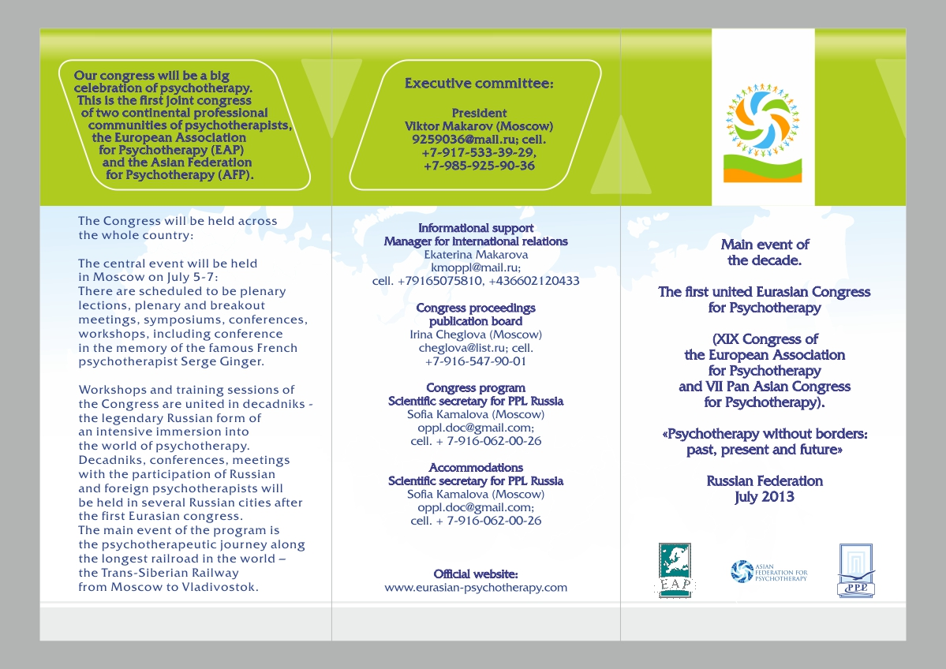


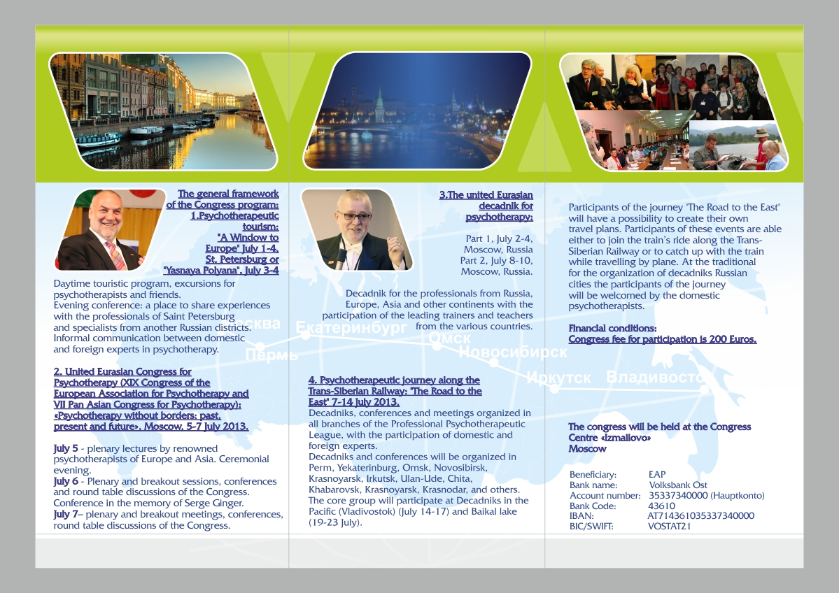
Congress Calender of the World Council for Psychotherapy
Europe | Organiser European Association for Psychotherapy
2013 | Moscow together with the Asian Chapter of the WCP |  |  | Russia
2015 | Athens |  |  | Greece
2016 | Zagreb |  |  | Croatia
2017 | Paris: World Congress for Psychotherapy planned  in cooperation with UNESCO |  |  | France
Asia | Organiser Asian Chapter of the World Council for Psychotherapy
2012 | New Dehli |  |  | India
2013 | Moscow  together with the European Association for Psychotherapy |  |  | Russia
2015 | Kuching |  |  | Malaysia
2016 | Teheran |  |  | Iran
Latin America |  |  | Organiser Federacion Latinoamerica di Psichoterapia
2013 | Quito |  |  | Ecuador
2015 | Sao Paulo |  |  | Brazil
2017 | La Paz |  |  | Bolivia
Africa |  | Organiser African Chapter of the World Council for Psychotherapy
2012 | Marrakech |  |  | Morocco
2012 | Bondo |  |  | Kenya
2014 | Durban  World Congress for Psychotherapy |  |  | South Africa
North America
2015 | Toronto |  |  | Canada

Delete box or place a tag line or quote here. Delete box or place a tag line or quote here.
Delete box or place a tag line or quote here.

MONTH, YEAR VOL # ISSUE #

Title: Psychotherapist effectiveness and professional competence not affected by their graduate studies profile – preliminary results.
Authors: Milena Karlińska-Nehrebecka, Alicja Heyda, Andrzej Nehrebecki, Dagmara Kuczynska-Ginko, Stanisława Kufel

...”Few people are capable of expressing with equanimity opinions which differ from the prejudices of their social environment. Most people are incapable of forming such opinions”...

Albert Einstein

Summary: Psychotherapists vary in terms of effectiveness and competence, but there has been little research to explore the psychotherapist features which actually contribute to his/her effectiveness and competence. A common opinion prevails both among the professional community and non-professionals that the profile of psychotherapist graduate studies is one of crucial factors. A research has been conducted to verify the assumption that psychotherapists who graduated medical, psychological or pedagogy studies are more effective and competent than other graduates of the humanities or natural sciences.

Breaking News: The following abstract draws attention to a piece of research to appear in the IJP (link on page 1).
Research sample and methods: The sample included 235 psychotherapist-patient dyads, where psychotherapists where students of the Integrative Psychotherapy School. Before they started training, they had graduated various MA studies: in psychology, pedagogy, theology, medicine, nursing, languages, law, other humanities or natural sciences. The subject of rating was a therapeutic session. After the session finished, the patient completed a rating scale concerning the psychotherapist and the session, including, alliance, “Rogerian” features, solution or a degree of being helpful. The psychotherapist competences were rated according to the rating scale regarding personal and technical competences, based on the observable criteria. Non-parametric methods (Mann-Whitney U Test) were used to calculate the results.
Results: the assumption that psychologists, doctors and pedagogy specialists are more effective and competent than the psychotherapists who graduated other studies in the humanities or natural sciences has not been confirmed. Thus, no empirical justification has been discovered to privilege the psychologists, doctors and pedagogy specialists when providing access to professional psychotherapist training.

Keywords: professional psychotherapist competences, psychotherapist, effectiveness of psychotherapy, rating scale, psychotherapist training

